HW2a

YL5090

Yuqiong Li

SEG1- Write up

# **Preprocessing:**

1. Order the speed data as time
2. Remove outliers
   1. This step is done by removing all points that are 3 standard deviation away from sample mean.
3. For NaN values, fill it with the last valid value before it
4. The circle of seasonality is 144. Remove seasonality by subtracting the value 144 time stamp away. Then remove the first 144 values as they are nan now.

Identification:

After cleaning data, now identify an ARIMA(p, d, q) model.

Step 1: First plot the time-series



After differentiating:



Use the Augmented Dickey-Fuller test to check existence of unit root:

ADF statistic: -12.819137

p-value: 0.000000

Critical Values:

1%: -3.431

5%: -2.862

10%: -2.567

Conclusion:

1. Differentiated data doesn’t seem to fit any upward or downward trend.
2. Augmented Dickey-Fuller test rejects null hypothesis. Thus no unit root. No time dependent structure.
3. Thus, now conclude stationary. Set d = 0.

# Step 2: Identify AR or MA process by plotting ACF and PACF for different lag values.

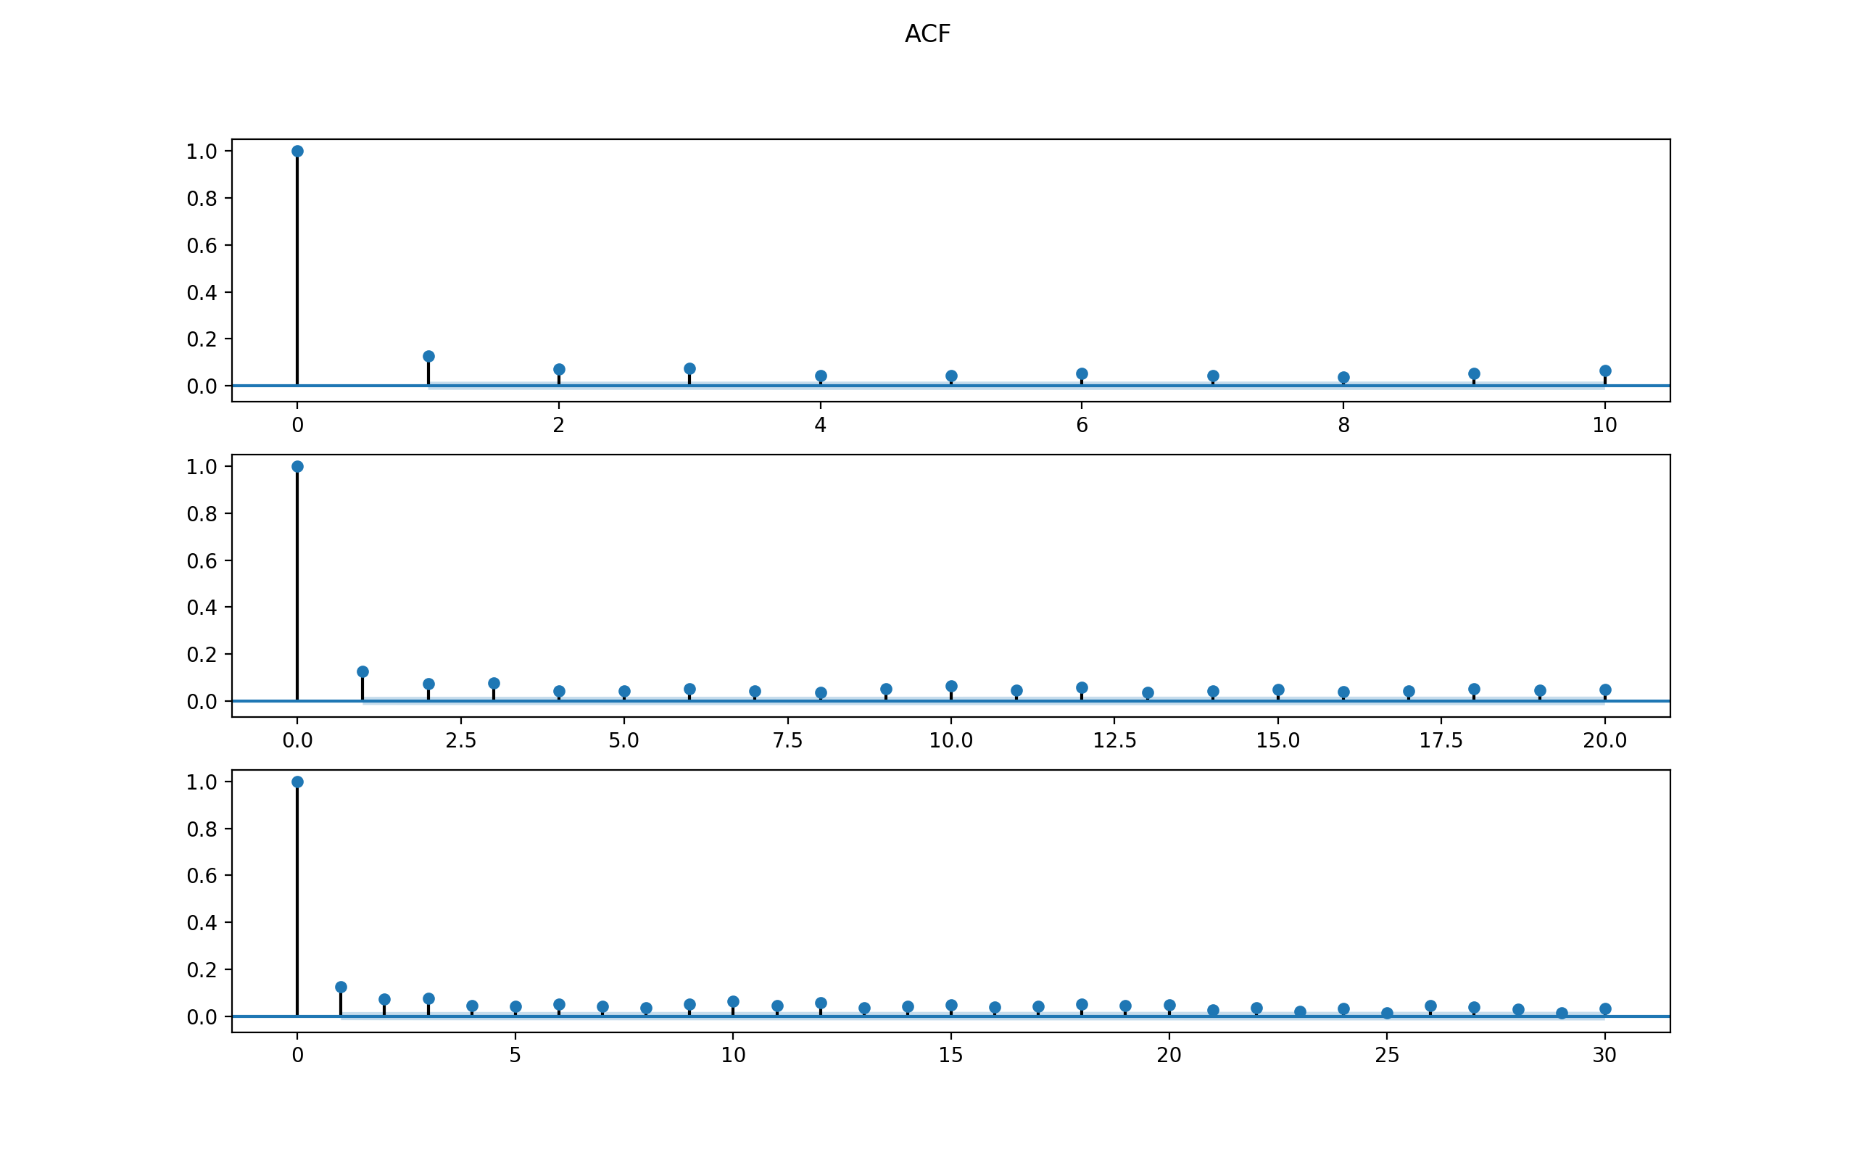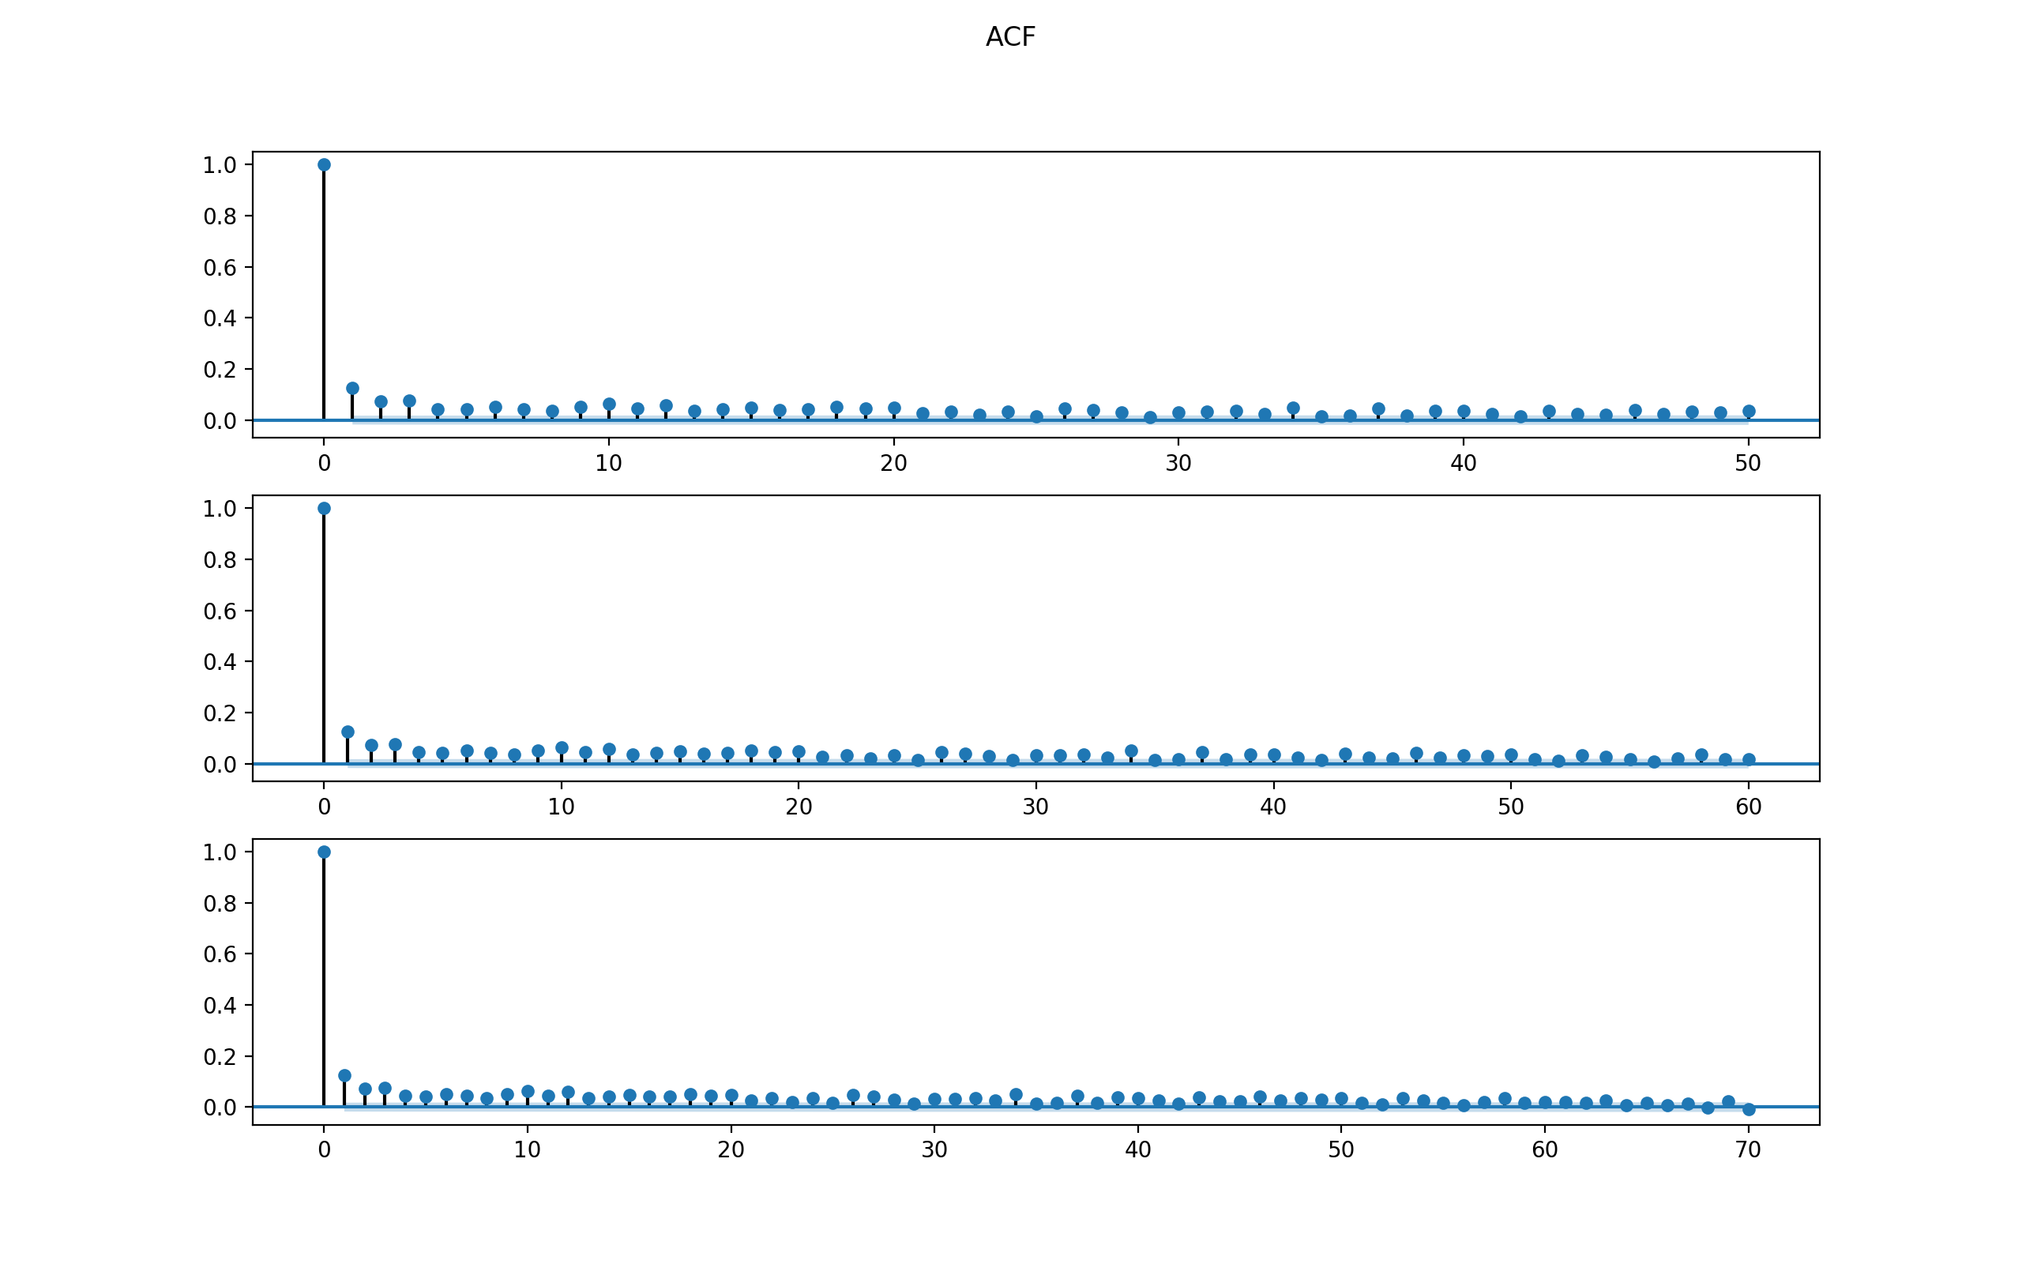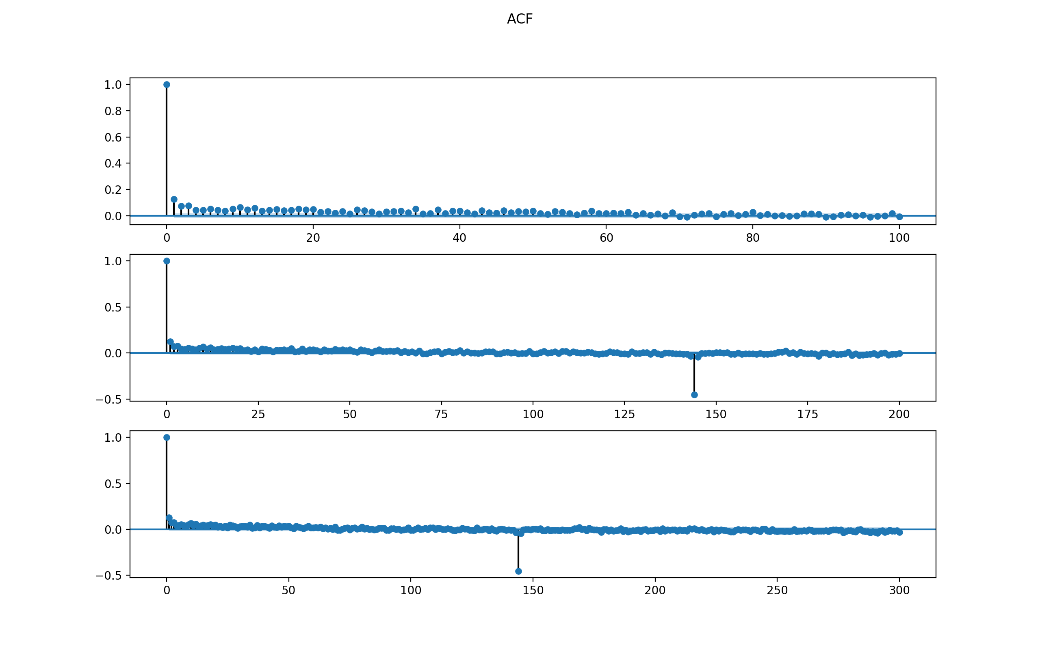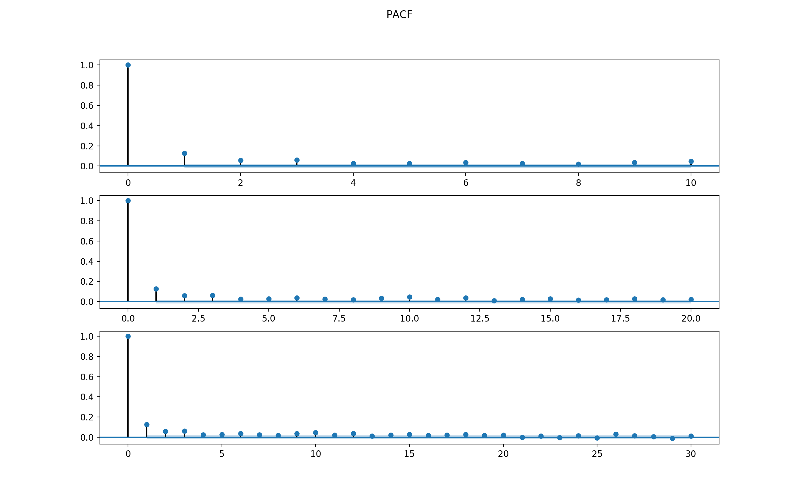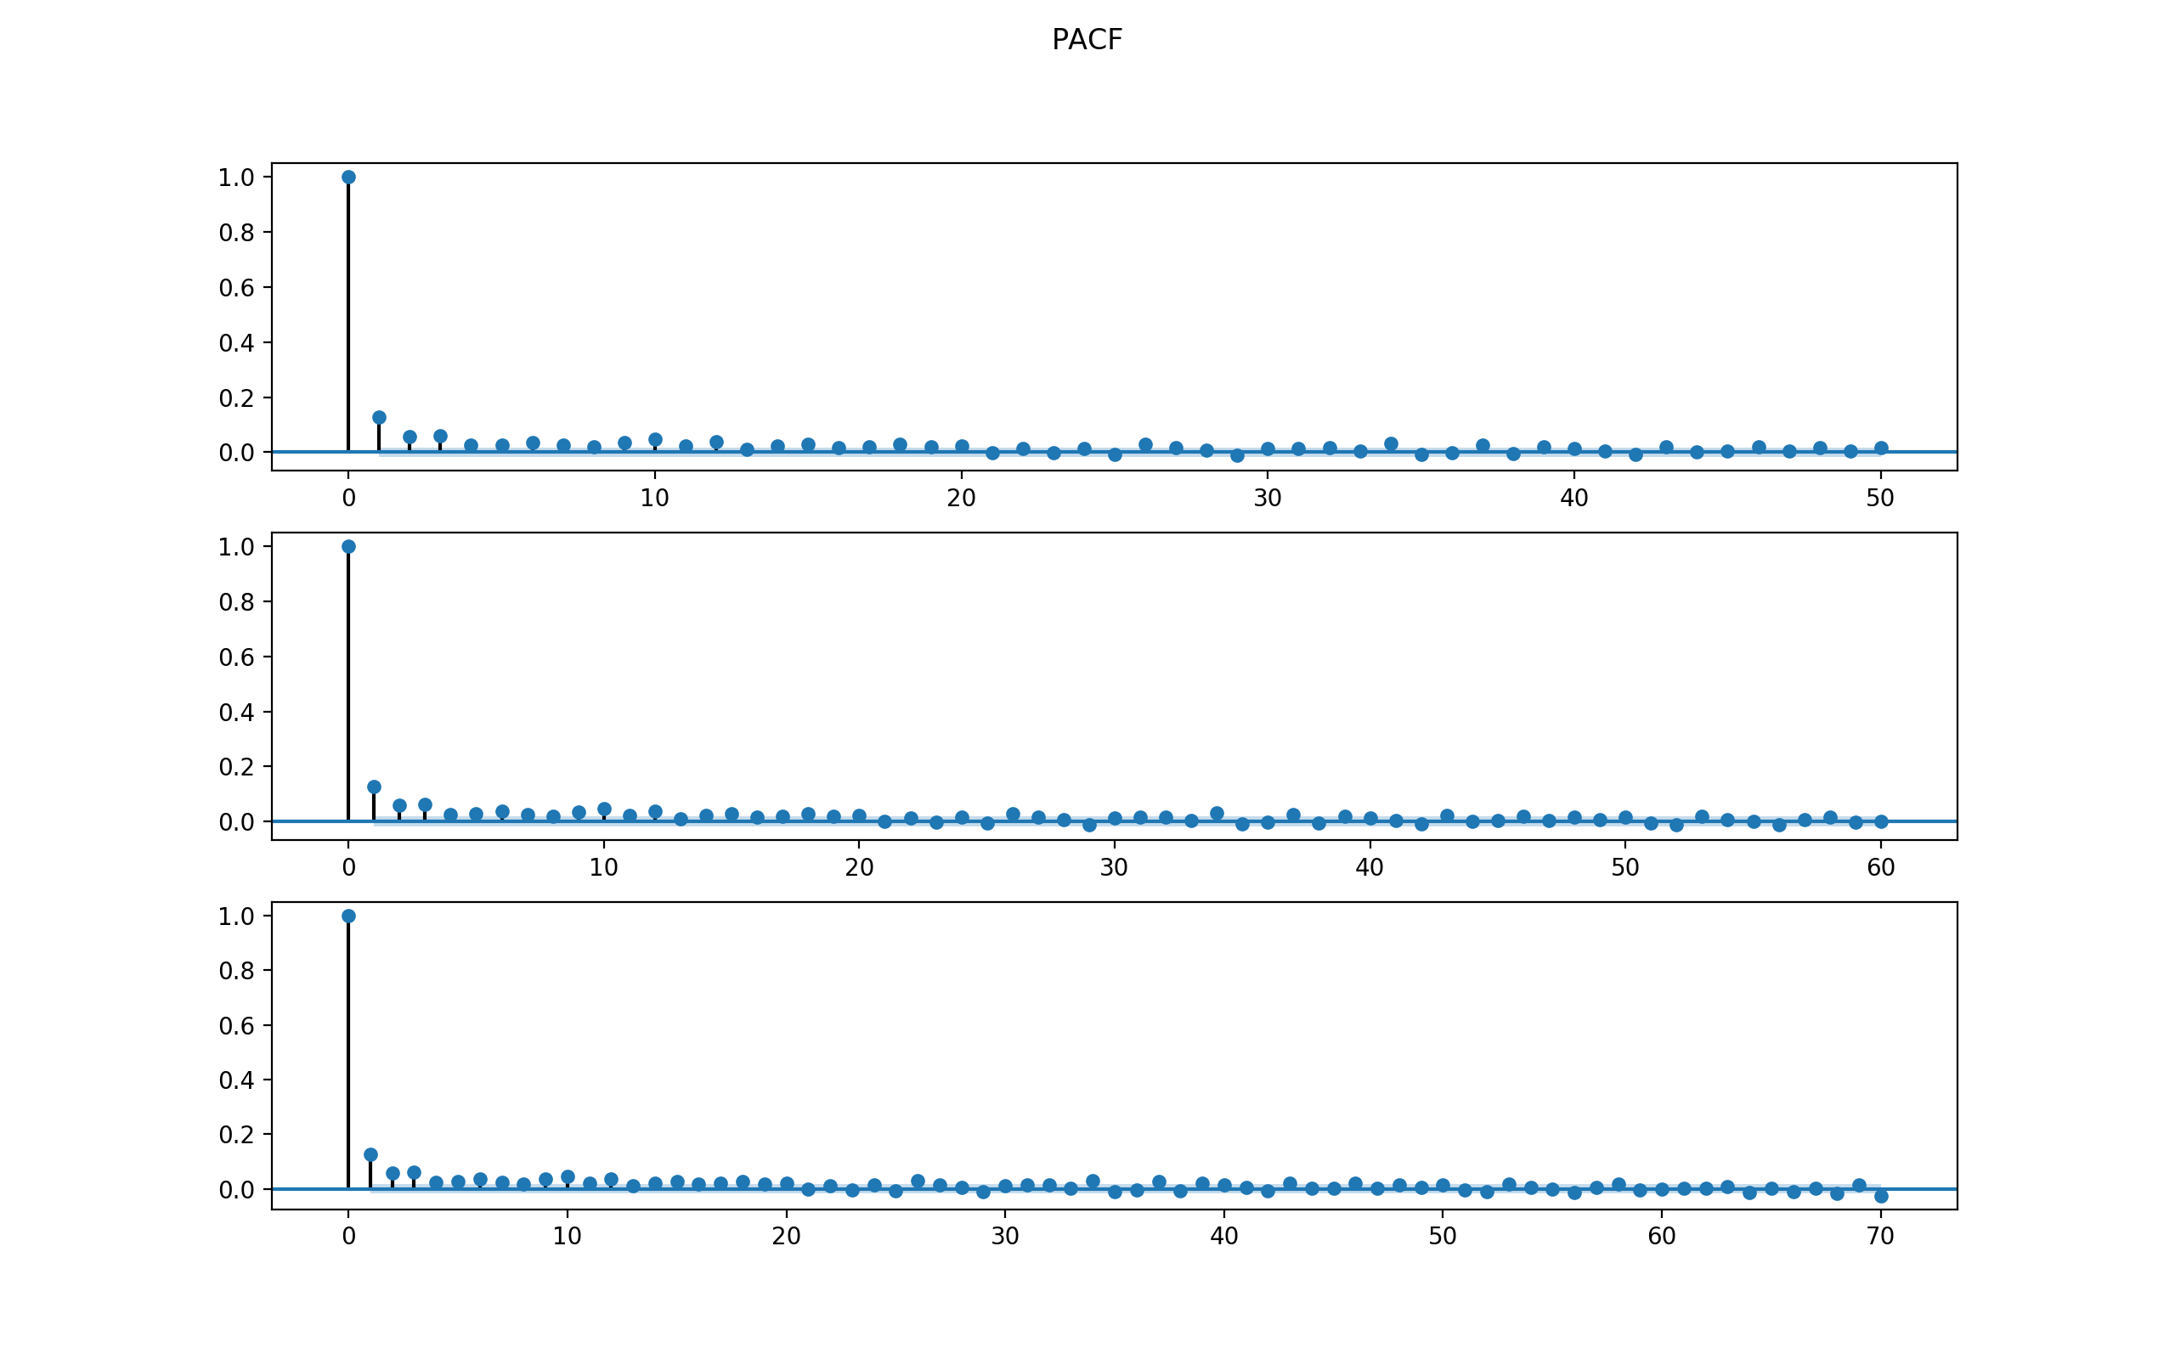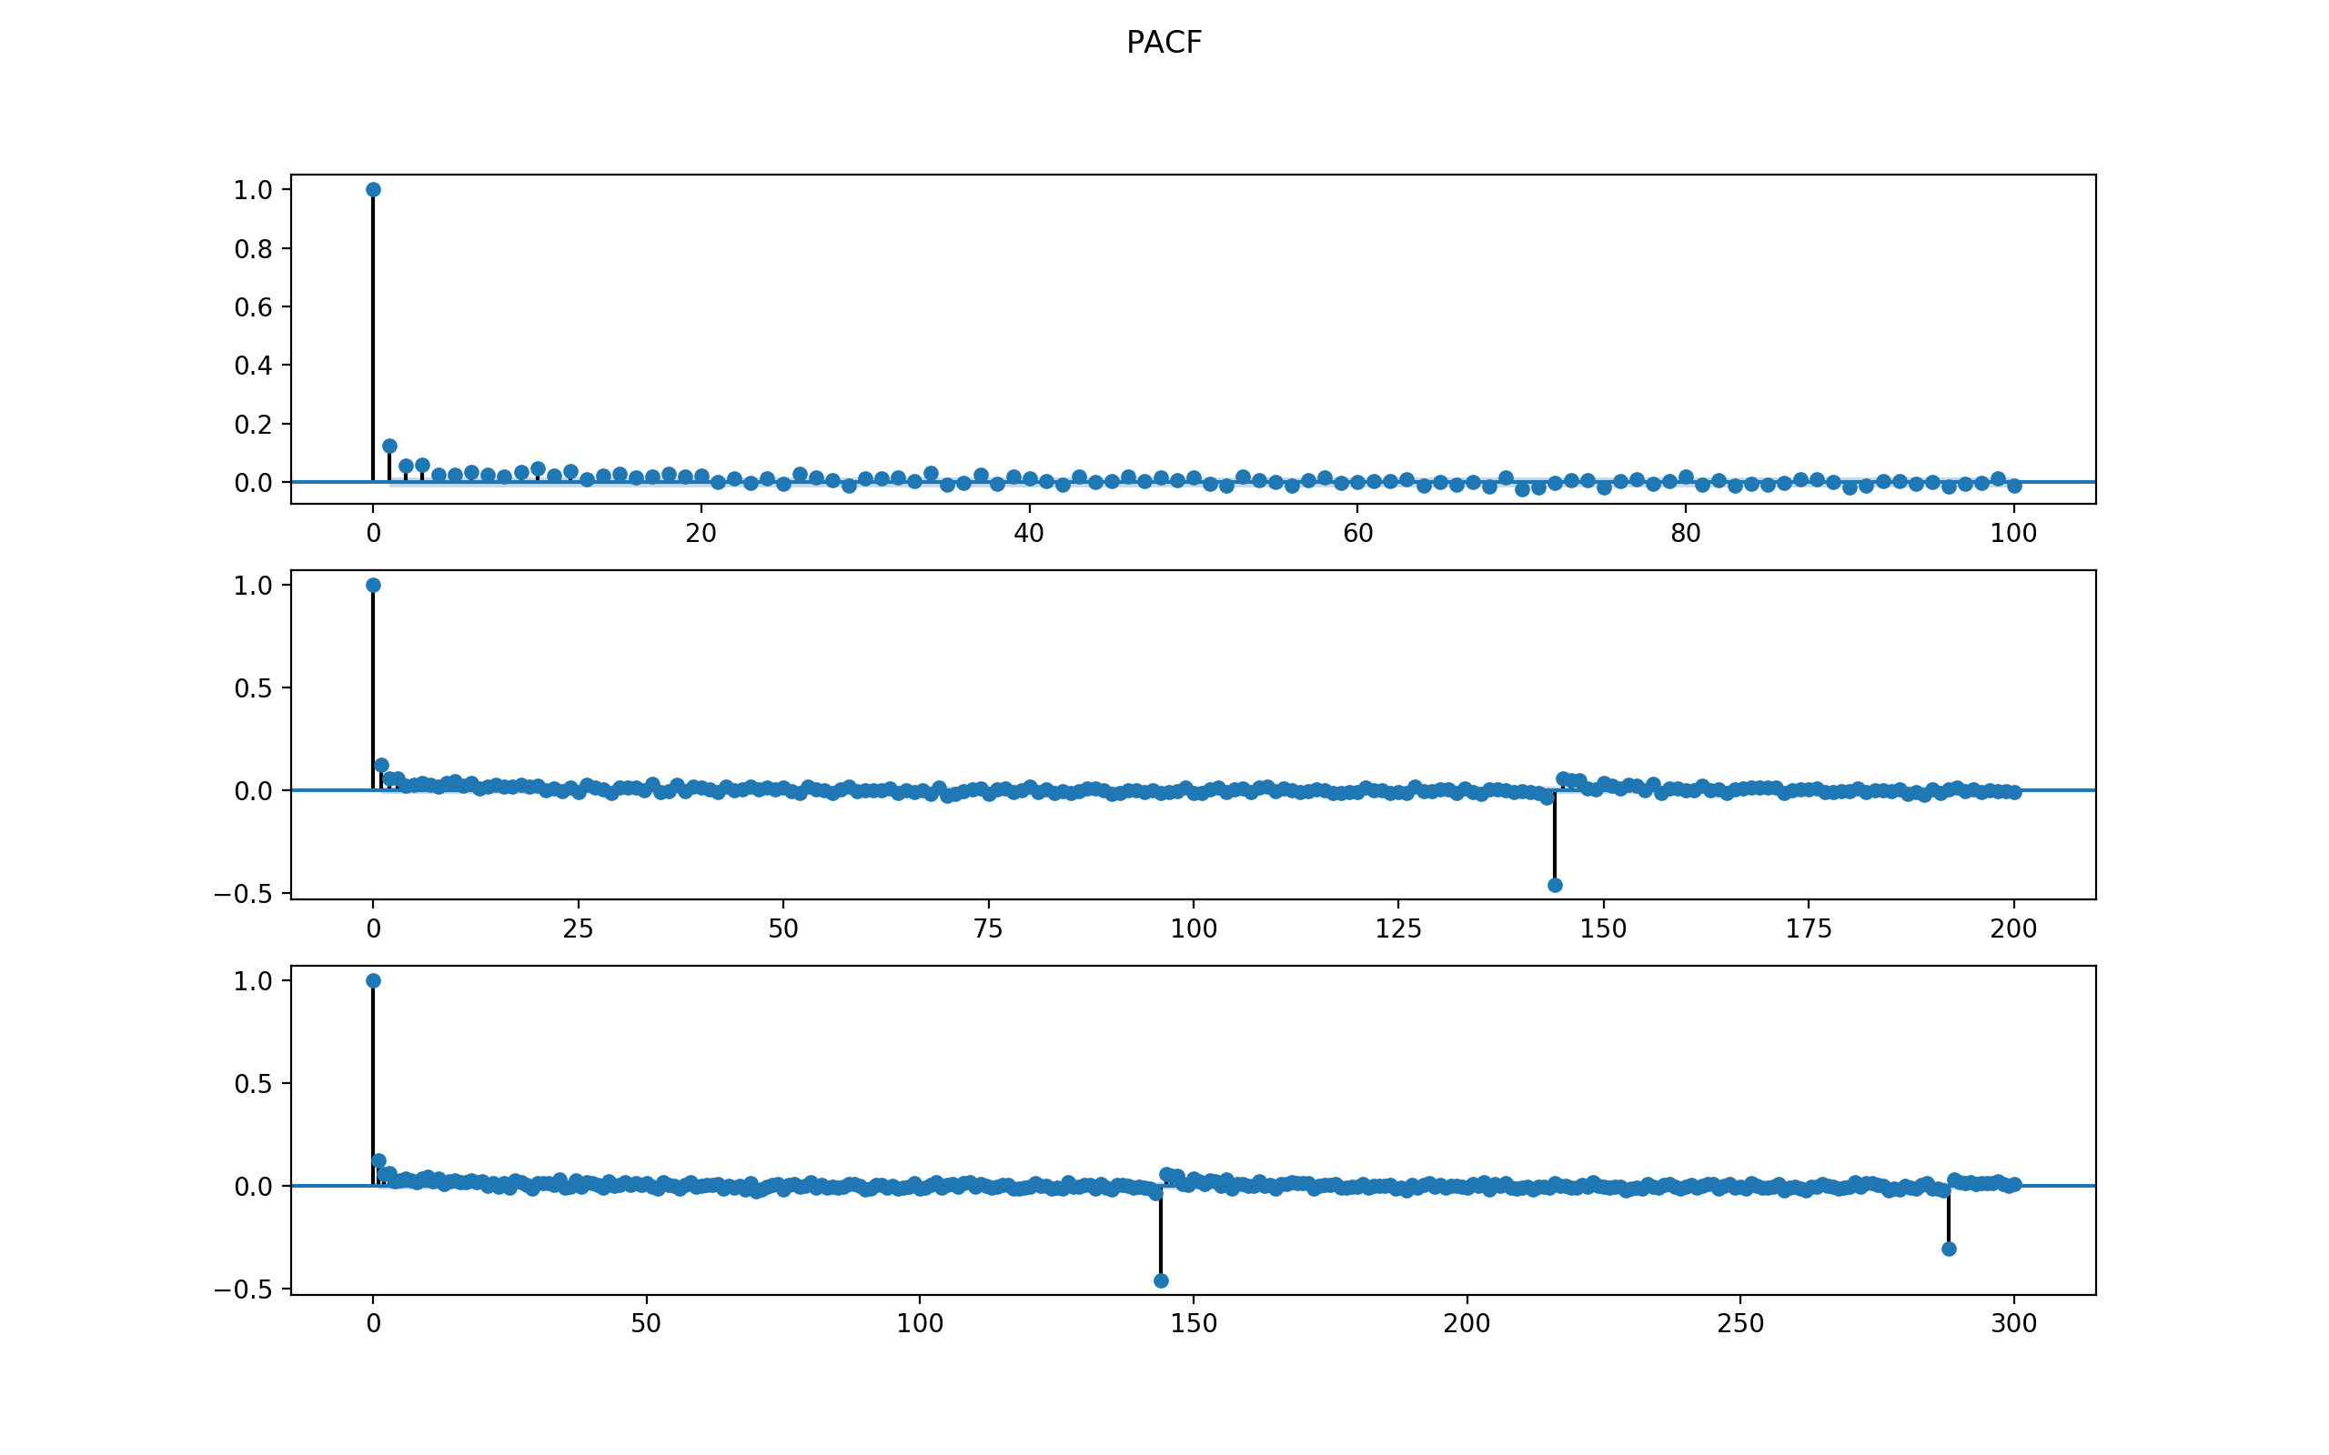

Observations:

1. ACF dies off, no cut off. Becomes zero after lag = 3 or so.
2. PACF dies off, no cut off. Becomes zero after lag = 3 or so.

Thus, the model might be a mixture of AR and MA, with p being at most 3 and q being at most 3.

Start from simple model for first stage filtering

* AR() of p being 1 to 3,
* MA() of q being 1 to 3,
* and also ARMA() combination of (p, q) each from 1 to 3

After filtering and selecting the lowest AIC and BIC for each family as well as the simplest model possible, decide to further compare three models below:

-----------------------------------------------------------------------------

ARMA Model Results

==============================================================================

Dep. Variable: Speed No. Observations: 8544

Model: ARMA(3, 0) Log Likelihood -26045.213

Method: css-mle S.D. of innovations 5.101

Date: Mon, 11 Dec 2017 AIC 52100.426

Time: 14:43:04 BIC 52135.691

Sample: 08-02-2014 HQIC 52112.457

- 09-30-2014

===============================================================================

coef std err z P>|z| [0.025 0.975]

-------------------------------------------------------------------------------

const 0.0152 0.071 0.213 0.831 -0.124 0.155

ar.L1.Speed 0.1299 0.011 12.018 0.000 0.109 0.151

ar.L2.Speed 0.0438 0.011 4.021 0.000 0.022 0.065

ar.L3.Speed 0.0513 0.011 4.750 0.000 0.030 0.073

Roots

=============================================================================

Real Imaginary Modulus Frequency

-----------------------------------------------------------------------------

AR.1 2.1580 -0.0000j 2.1580 -0.0000

AR.2 -1.5054 -2.6003j 3.0046 -0.3335

AR.3 -1.5054 +2.6003j 3.0046 0.3335

ARMA Model Results

==============================================================================

Dep. Variable: Speed No. Observations: 8544

Model: ARMA(0, 3) Log Likelihood -26049.573

Method: css-mle S.D. of innovations 5.104

Date: Mon, 11 Dec 2017 AIC 52109.145

Time: 14:43:05 BIC 52144.410

Sample: 08-02-2014 HQIC 52121.176

- 09-30-2014

===============================================================================

coef std err z P>|z| [0.025 0.975]

-------------------------------------------------------------------------------

const 0.0151 0.069 0.221 0.825 -0.119 0.149

ma.L1.Speed 0.1293 0.011 11.955 0.000 0.108 0.150

ma.L2.Speed 0.0576 0.011 5.374 0.000 0.037 0.079

ma.L3.Speed 0.0540 0.010 5.238 0.000 0.034 0.074

Roots

=============================================================================

Real Imaginary Modulus Frequency

-----------------------------------------------------------------------------

MA.1 -2.7081 -0.0000j 2.7081 -0.5000

MA.2 0.8207 -2.4833j 2.6154 -0.1992

MA.3 0.8207 +2.4833j 2.6154 0.1992

ARMA Model Results

==============================================================================

Dep. Variable: Speed No. Observations: 8544

Model: ARMA(3, 2) Log Likelihood -25999.923

Method: css-mle S.D. of innovations 5.073

Date: Mon, 11 Dec 2017 AIC 52013.846

Time: 14:43:56 BIC 52063.217

Sample: 08-02-2014 HQIC 52030.690

- 09-30-2014

===============================================================================

coef std err z P>|z| [0.025 0.975]

-------------------------------------------------------------------------------

const 0.0163 0.124 0.131 0.896 -0.228 0.260

ar.L1.Speed 0.0732 0.015 4.740 0.000 0.043 0.103

ar.L2.Speed 0.9684 0.007 142.590 0.000 0.955 0.982

ar.L3.Speed -0.0886 0.012 -7.521 0.000 -0.112 -0.066

ma.L1.Speed 0.0534 0.011 4.961 0.000 0.032 0.074

ma.L2.Speed -0.9466 0.011 -88.002 0.000 -0.968 -0.926

Roots

=============================================================================

Real Imaginary Modulus Frequency

-----------------------------------------------------------------------------

AR.1 -1.0076 +0.0000j 1.0076 0.5000

AR.2 1.0266 +0.0000j 1.0266 0.0000

AR.3 10.9105 +0.0000j 10.9105 0.0000

MA.1 -1.0000 +0.0000j 1.0000 0.5000

MA.2 1.0564 +0.0000j 1.0564 0.0000

-----------------------------------------------------------------------------

The final chosen model is ARMA(3, 2) because 1) it has lowest BIC and AIC among the three.

Check the residuals to see if the model makes sense.

For ARMA(3, 2) model for SEG1, the 4-plot of residuals are below.

The MSE is 111451.72620640961.

The conclusion is that the residuals are not normal. Thus ARMA(3,2) might not be a good fit.

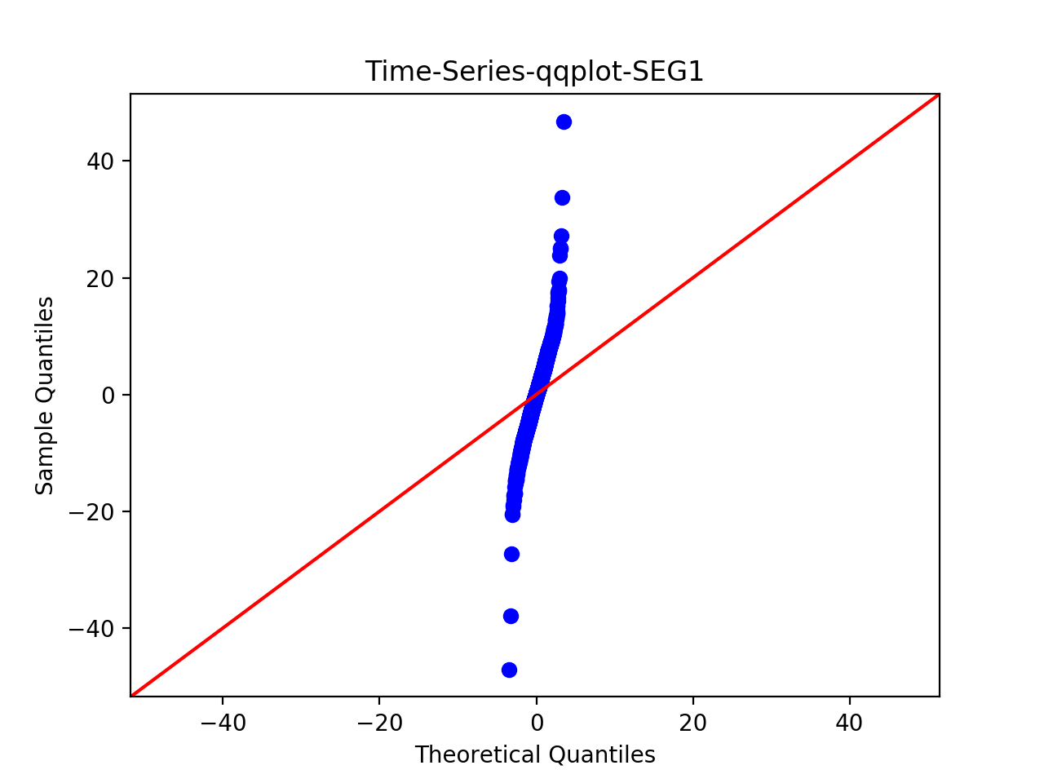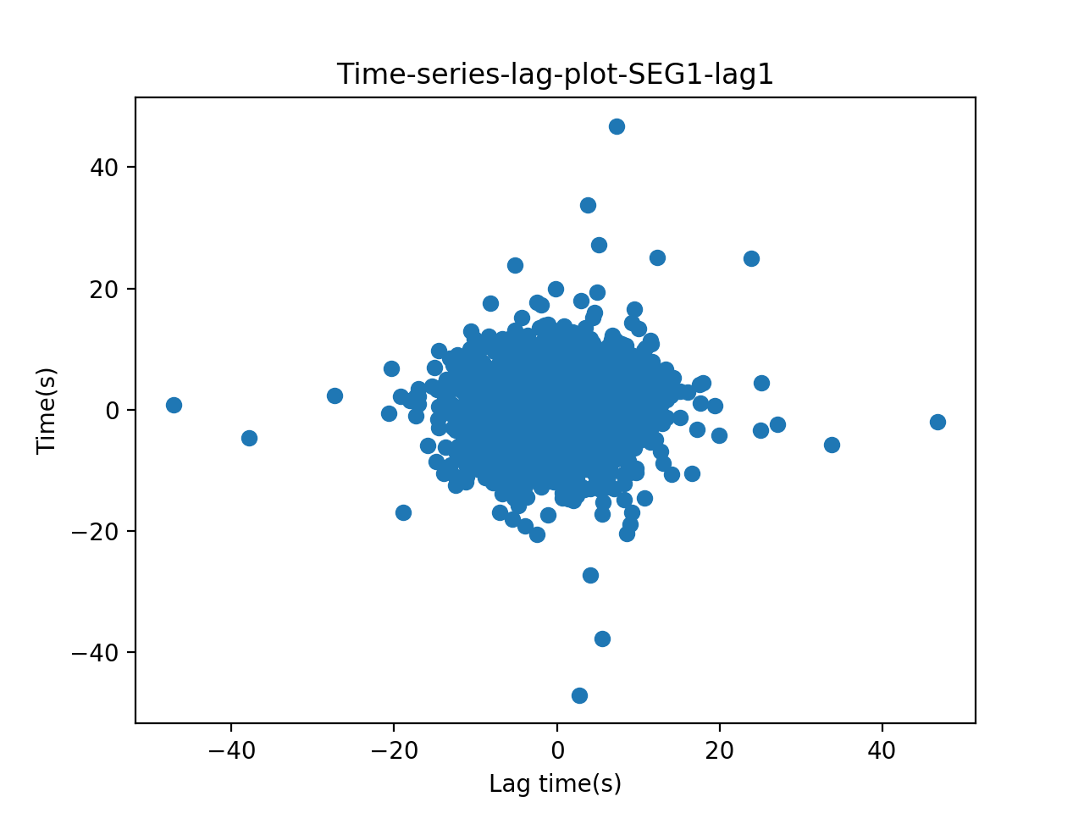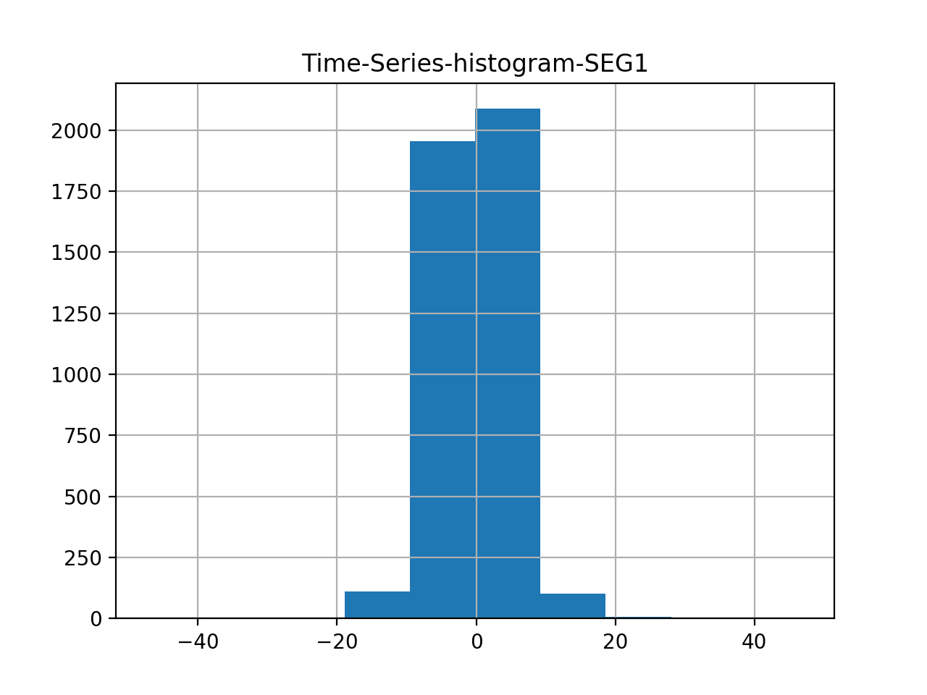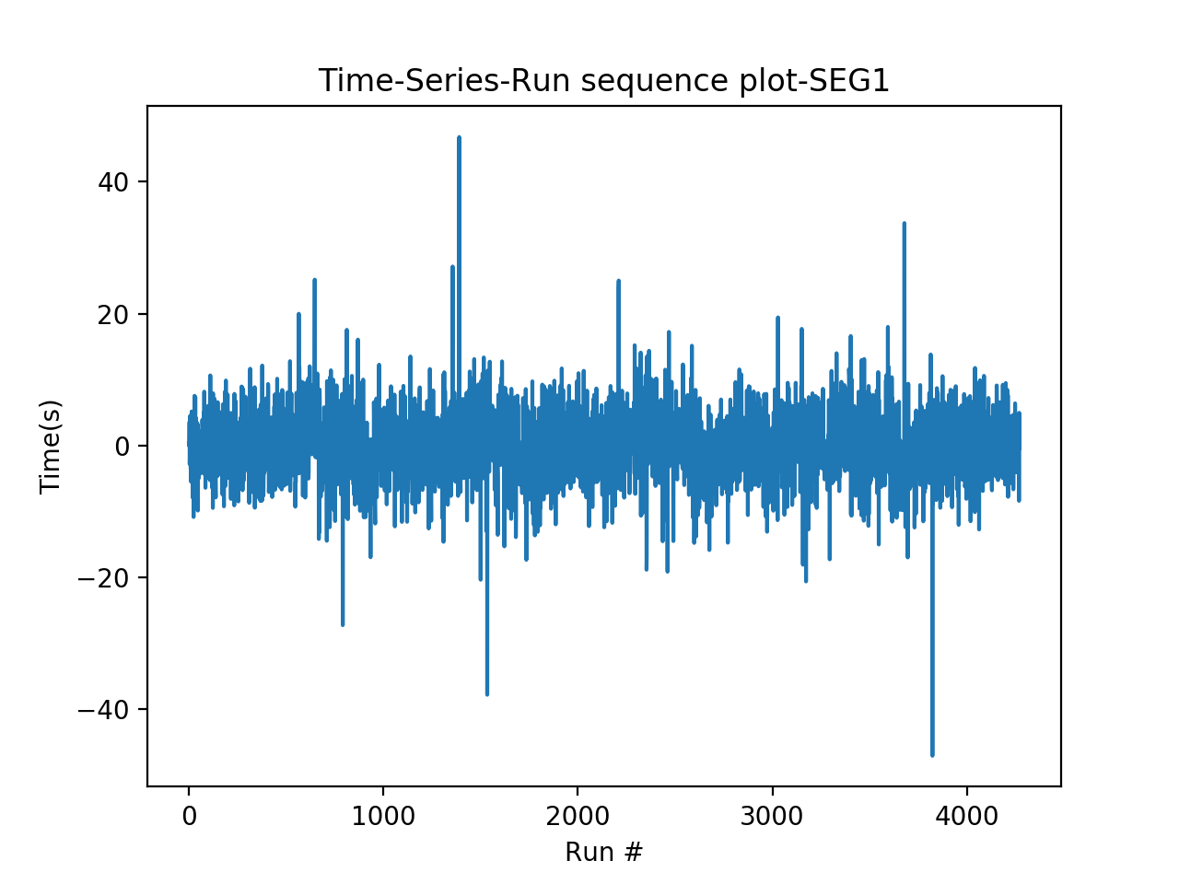

Use Chi-square goodness of fit and set number of bins = 200, results:

Power_divergenceResult(statistic=28445.423606210305, pvalue=0.0)

The p-value is smaller than 0.05, thus reject null. Thus there is a significant difference between the two data series – thus this model is not a good fit.

# Step 3: Test for OLS regression model, using mllib.

Data transformation: to run regression, since previous fit an ARMA(3,2) model, now use past 3 day’s value as features.

For training data, the mean Squared Error = 26.0267320002

For test data, Mean Squared Error = 25.6217946073

Thus, use MLlib for chi-square test returns the following results:

>>> pearson.pValue

0.0

>>> pearson.statistic

inf

Conclude that regression on a single past value is not a good fit, although the MSE value is small.

# Step 4: Test for Ridge regression model, using mllib.

Again using past three day’s value as feature.

For training data, the mean Squared Error = 26.0267320002

For test data, Mean Squared Error = 25.6217946073

Thus, use MLlib for chi-square test returns the following results:

>>> pearson.pValue

0.0

>>> pearson.statistic

inf

Conclude that ridge regression on a single past value is also not a good fit, although the MSE values are small.

# Step 5: Test for Lasso regression model, using mllib.

Again using past three day’s value as feature.

For training data, the mean Squared Error = 26.0267320002

For test data, Mean Squared Error 25.6217946073

Thus, use MLlib for chi-square test returns the following results:

>>> pearson.pValue

0.0

>>> pearson.statistic

inf

Conclude that Lasso regression on a single past value is also not a good fit.

Conclusion for Step 3 – Step 5:

Ridge, OLS, and Lasso seem to generate similar results. The MSE is 25.6217946073.

ARMA(3, 2) model, the MSE for test data is 111451.72620640961.